Yeast 2-micron plasmid
The 2-micron plasmid of Saccharomyces cerevisiae is also called the 2µ circle. The 2µ circle is a 6.3 kb circular, extrachromosomal element found in the nucleus of most Saccharomyces cerevisiae strains.
The 2µ circle doesn't give cells that carry it any apparent selective advantage, but it is stably maintained at about 40-60 copies per haploid genome of the yeast cells.
Like the host chromosomes, the 2µ circle is coated with nucleosomes and replication is initiated by host replication enzymes once per cell cycle.
The origin of bidirectional DNA replication is initiated at a specific site on the plasmid called an ARS sequence ("autonomous replication sequence").
The plasmid is able to persist in host populations with almost chromosome-like stability with the help of a partitioning system and a copy number control system.

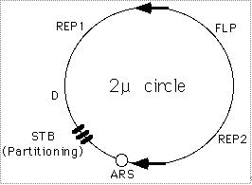
Figure: A cartoon of the yeast 2µ circle showing the ARS, the FLP gene, the three genes which encode proteins required for regulation of FLP expression (REP2, REP1, and D), and a set of small direct repeats (called "STB") required for partitioning into daughter cells during mitosis and meiosis.
The high copy number of the 2µ circle poses a problem because in eukaryotic cells DNA replication is only initiated once per cell cycle. Once initiated, bidirectional replication continues until the two replication forks collide on the opposite side of the circular plasmid.
The 2µ circle has a site-directed inversion mechanism that allows plasmid amplification. The 2µ circle has two copies of a 599 bp inverted repeat sequence (called "flip" sites) and encodes a site-directed recombinase called FLP (the "flip" protein) that promotes recombination between these repeats. Recombination between the flip sequences inverts the adjacent regions of the plasmid as shown in the figure below.

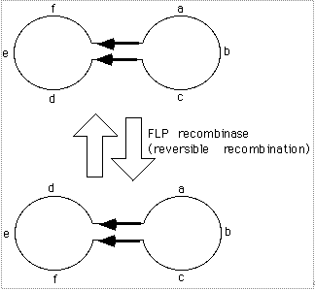

This inversion allows the plasmid to switch from bidirectional-replication to rolling circle replication, producing multiple copies of the plasmid each cell cycle.
The origin of replication is located very close to one of the flip sites, so one replication fork will pass through the adjacent flip soon after replication has begun, but the second replication fork has to travel half way around the plasmid before it passes through the other flip site.
After one of the bidirectional DNA replication forks has passed the first flip site but before the replicating fork reaches the second flip site, recombination inverts the intervening sequence -- after this inversion, both of the DNA replication forks will be moving in the same direction.
Continued replication produces long concatemers which can be converted to monomeric plasmids by site-specific recombination.
Replication is finally terminated when a second inversion occurs between the flip sites, causing the replication forks to collide.
The end result is that many plasmid molecules are produced from a single initiation of DNA replication.
Three plasmid encoded proteins (REP1, REP2, and D) modulate the plasmid copy number by repressing expression of FLP protein. The concentration of the repressor proteins is proportional to copy number of the 2µ circle. Thus, when the plasmid copy number is high, expression of FLP is repressed, but when the plasmid copy number is low, expression of FLP is induced.
Appropriate plasmid amplification, without runaway (uncontrolled) increase in copy number, is ensured by positive and negative regulation of FLP gene expression by plasmid coded proteins and by the control of Flp level/activity through post-translational modification of Flp by the cellular sumoylation system.
The control of plasmid copy number in bacteria is usually regulated by modulating the initiation of DNA replication, but in contrast the yeast 2µ circle controls plasmid copy number by regulating a protein which affects amplification of the plasmid.
The Rep-STB system couples plasmid segregation to chromosome segregation by promoting the physical association of plasmid molecules with chromosomes.

